Curriculum Vitae
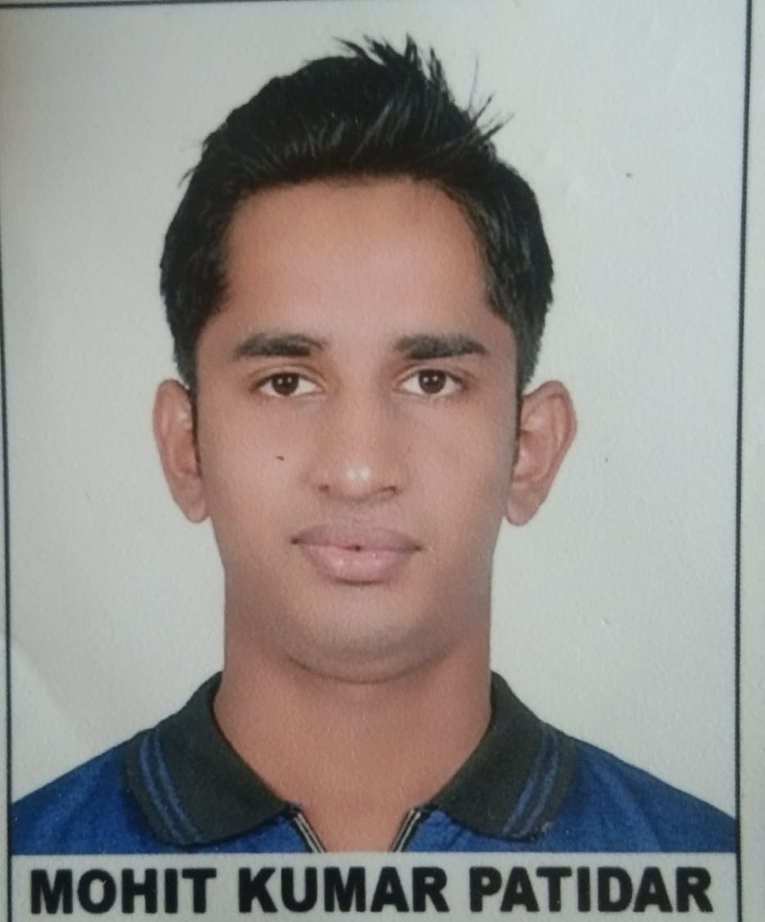
MOHIT KUMAR PATIDAR
Contact & Address:
Mobile No: 6377479337
E-mail:mk8820@srmist.edu.in

Address: Teacher colony zirapur
Distt: Rajgarh(MP)
Postal code: 465691

Objective
To work for an organization which provides me the opportunity to improve my skills and knowledge to growth along with the organization objective. To give my best and will be honest for that organization.
Education
Course : B.Tech in Computer Science Engineering
Session : 2019-2023
Institute : SRM Institute of Science and Technology Chennai (Tamilnadu).
Average : 9.3 CGPA (First + Second + Third Sem)
Board Exam : XII(10+2)
Board : State Board(MP)
Session : 2017-2018
School : Royal Heights Higher Secondary School (Zirapur)
Stream : PCM
Marks : 401/500
Board Exam : X(10
Board : State Board(MP)
Session : 2015-2016
School : Vijaya Convent High School (Zirapur).
Marks : 531/600
Computer Skills
- C,C++
- PYTHON
- JAVASCRIPT
- HTML
- CSS
Languages Proficiency & Hobbies.

Good command over English & Hindi. Love to solve aptitude problem, listen music and reading books.

